Ansible Tasks-02
- Watch ansible-02 video and write down notes.
- Install httpd using ansible playbook, use handlers,notifiers.
- Write a ansible playbook to install apache tomcat.
- Write a ansible playbook to provision one ec2 on aws.
- Write a ansible playbook to copy one file from node-1 to node-2.
- Write a ansible playbook to create different files with different names using single playbook.

Ansible Playbooks — Notes
1. What is Ansible?
Ansible is an open-source automation tool used to configure servers, install software, deploy applications, and automate repetitive IT tasks.
Main uses:
- Configuration management
- Application deployment
- Software installation
- Server provisioning
- Task automation
2. Ansible Architecture
Control Node: The machine where Ansible is installed and playbooks are executed.
Managed Nodes: The remote servers managed by Ansible.
Inventory: A file containing managed server IP addresses and connection details.
SSH: Used to connect to Linux managed nodes.
Modules: Perform tasks such as installing packages, copying files, and managing services.
3. What is an Ansible Playbook?
An Ansible playbook is a YAML file containing instructions to automate tasks on one or more managed nodes.
Playbooks commonly use the .yml or .yaml extension.
Example:
---
- name: Install Apache web server
hosts: workers
become: true

tasks:
- name: Install Apache
ansible.builtin.apt:
name: apache2
state: present
update_cache: true
Explanation:
- --- — Marks the beginning of a YAML document.
- name — Describes the play or task.
- hosts — Specifies the target group from the inventory.
- become: true — Runs tasks with elevated privileges.
- tasks — Contains the operations to execute.
- ansible.builtin.apt — Manages packages on Debian/Ubuntu systems.
- state: present — Ensures the package is installed.
Note: On Amazon Linux or RHEL, use the appropriate package manager, such as ansible.builtin.dnf.
4. Important Ansible Modules
Module | Purpose
ansible.builtin.apt | Install or remove packages on Debian/Ubuntu
ansible.builtin.dnf | Manage packages on supported RPM-based systems
ansible.builtin.service | Manage services
ansible.builtin.copy | Copy files to managed nodes
ansible.builtin.file | Create files/directories and manage permissions
ansible.builtin.template | Deploy files using Jinja2 templates
ansible.builtin.command | Execute commands
ansible.builtin.user | Manage user accounts
ansible.builtin.debug | Display messages and variable values
5. Inventory File
The inventory identifies the servers on which playbooks will run.
Example:
[workers]
worker1 ansible_host=WORKER1_PRIVATE_IP
worker2 ansible_host=WORKER2_PRIVATE_IP

[workers:vars]
ansible_user=ansadm
ansible_python_interpreter=/usr/bin/python3
Replace the placeholder IP addresses with your actual worker private IPs.
Test connectivity:
ansible workers -i inventory -m ping
Expected result: Both workers should return SUCCESS with "ping": "pong".
6. How to Execute a Playbook
Create a playbook:
nano install-apache.yml
Run the playbook:
ansible-playbook -i inventory install-apache.yml
Check the result:
ansible workers -i inventory -m ping
Common execution options:
ansible-playbook --syntax-check install-apache.yml
ansible-playbook -i inventory install-apache.yml --check
The syntax check validates the playbook structure. Check mode simulates supported changes, but not every module supports full simulation.
7. Handlers and Notify
A handler is a special task that runs only when notified by a task that reports a change.
Example:
---
- name: Configure Apache
hosts: workers
become: true

tasks:
- name: Install Apache
ansible.builtin.apt:
name: apache2
state: present
update_cache: true

- name: Update Apache configuration
ansible.builtin.copy:
content: "ServerName localhost\n"
dest: /etc/apache2/conf-available/servername.conf
notify: Restart Apache

handlers:
- name: Restart Apache
ansible.builtin.service:
name: apache2
state: restarted
Important points:
- notify triggers a handler when the associated task changes something.
- The handler name must match the notification name.
- Handlers normally run at the end of the play.
- Multiple notifications for the same handler are generally consolidated into one execution per play.
- If a task makes no change, its handler is not triggered.
8. Loops in Ansible
Loops allow us to repeat a task for multiple values without writing the same task repeatedly.
Example:
---
- name: Create multiple files
hosts: workers
become: true

tasks:
- name: Create files
ansible.builtin.file:
path: "/tmp/{{ item }}"
state: touch
loop:
- file1.txt
- file2.txt
- file3.txt
This playbook creates three files using one task.
9. Variables
Variables allow us to reuse values and customize playbooks.
Example:
---
- name: Install a package
hosts: workers
become: true

vars:
package_name: apache2

tasks:
- name: Install package
ansible.builtin.apt:
name: "{{ package_name }}"
state: present
The {{ package_name }} expression references the variable value.
10. Idempotency
Idempotency means running a playbook repeatedly should leave the system in the desired state without making unnecessary changes.
For example, using state: present ensures a package is installed rather than reinstalling it every time.
11. Ansible Playbook Workflow
- Create an inventory file.
- Verify connectivity to managed nodes.
- Write the YAML playbook.
- Check YAML indentation and syntax.
- Run the playbook.
- Review the output for failures or changes.
- Verify the application, file, or service on the managed node.
12. Summary
- Ansible automates server administration.
- Playbooks define tasks in YAML.
- Inventory specifies target servers.
- Modules perform the actual operations.
- Handlers run in response to notifications.
- Loops repeat tasks for multiple values.
- Variables make playbooks reusable.
- Idempotency helps avoid unnecessary changes.
- Always validate and verify playbook execution.

Task 2: Install HTTPD Using an Ansible Playbook with Handlers and Notify
Objective: Install HTTPD (Apache Web Server) on both worker nodes using an Ansible playbook. Use a handler and the notify directive to restart HTTPD when the web page changes.
Step 1: Connect to the Ansible Master
Log in to your Ansible master EC2 instance and navigate to your existing lab directory.
cd ~/ansible-lab
Check your inventory file:
cat inventory
Ensure that both worker nodes and their private IP addresses are configured correctly.
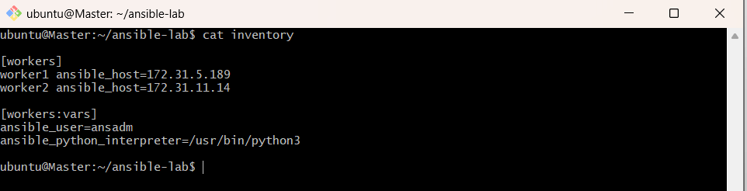
Step 2: Verify the Operating System
Run this command from the master:
ansible workers -i inventory -m setup -a 'filter=ansible_distribution'
This guide assumes both workers are running Amazon Linux 2023. If they run Ubuntu, the package and service configuration will differ.
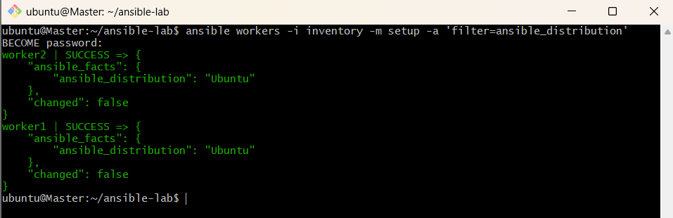
Step 3: Create the Ansible Playbook
Create a file named install-httpd.yml:
nano install-httpd.yml
Paste the following content:

---
- name: Install HTTPD using Ansible
hosts: workers
become: true

tasks:
- name: Install HTTPD package
ansible.builtin.dnf:
name: httpd
state: present

- name: Configure the HTTPD welcome page
ansible.builtin.copy:
content: "HTTPD installed using Ansible on {{ inventory_hostname }}\n"
dest: /var/www/html/index.html
owner: apache
group: apache
mode: "0644"
notify: Restart HTTPD

- name: Ensure HTTPD is running and enabled
ansible.builtin.service:
name: httpd
state: started
enabled: true

handlers:
- name: Restart HTTPD
ansible.builtin.service:
name: httpd
state: restarted
Save the file by pressing Ctrl + O, then Enter, and Ctrl + X.
Key concepts
- hosts: workers — Runs the playbook on both worker nodes.
- become: true — Executes tasks with elevated privileges.
- dnf — Installs the HTTPD package on Amazon Linux 2023.
- notify: Restart HTTPD — Notifies the handler when the welcome page changes.
- handlers — Defines tasks that run when notified.
- state: started — Ensures HTTPD is running.
- enabled: true — Enables HTTPD to start automatically after reboot.
Step 4: Validate the Playbook Syntax
Run:
ansible-playbook -i inventory install-httpd.yml --syntax-check
Expected output:
playbook: install-httpd.yml
If there are YAML errors, correct them before proceeding.

Step 5: Execute the Playbook
Run:
ansible-playbook -i inventory install-httpd.yml
Review the output for both workers. The playbook recap should show:
- failed=0
- No unreachable hosts
- changed tasks during the initial run, where applicable
The handler should run when the welcome page is created or modified.
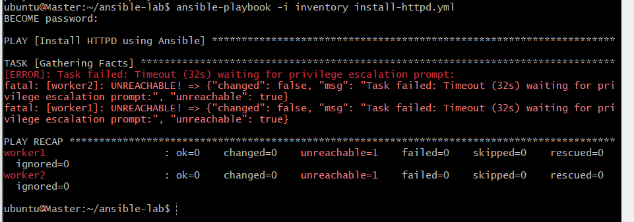
Step 6: Verify HTTPD Is Running
Run on the Master:
ansible workers -i inventory -b -m command -a "systemctl is-active apache2"
Expected output:
worker1 | CHANGED | rc=0 >>
active

worker2 | CHANGED | rc=0 >>
active
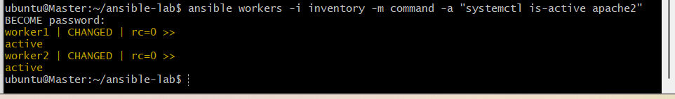
Step 7: Verify the Apache Welcome Page
Run on Master:
ansible workers -i inventory -m command -a "cat /var/www/html/index.html"
Expected output currently shows the default Ubuntu Apache page:
worker1 | SUCCESS
<title>Apache2 Ubuntu Default Page: It works</title>

worker2 | SUCCESS
<title>Apache2 Ubuntu Default Page: It works</title>
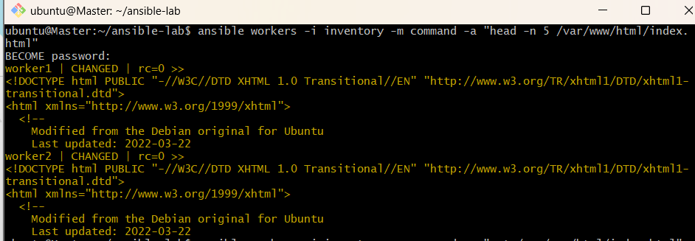
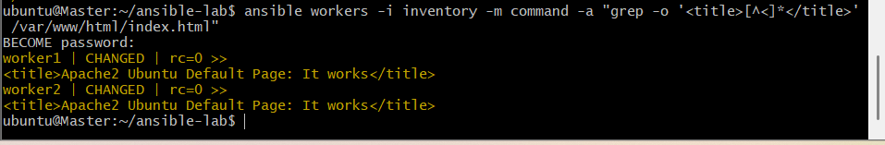

Step 8: Update the playbook
On your Master, run:
cd ~/ansible-lab
nano install-httpd.yml
Replace the entire file with this Ubuntu-compatible playbook:

---
- name: Install Apache using Ansible
hosts: workers
become: true

tasks:
- name: Install Apache package
ansible.builtin.apt:
name: apache2
state: present
update_cache: true

- name: Create custom Apache welcome page
ansible.builtin.copy:
content: "Apache installed using Ansible on {{ inventory_hostname }}\n"
dest: /var/www/html/index.html
owner: www-data
group: www-data
mode: "0644"
notify: Restart Apache

- name: Ensure Apache is running and enabled
ansible.builtin.service:
name: apache2
state: started
enabled: true

handlers:
- name: Restart Apache
ansible.builtin.service:
name: apache2
state: restarted
Save the file using Ctrl+O, press Enter, then Ctrl+X.
Step 9: Check playbook syntax
ansible-playbook -i inventory install-httpd.yml --syntax-check
Expected:
playbook: install-httpd.yml
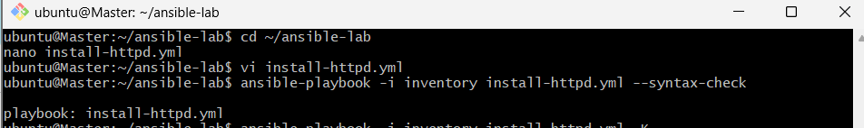
Step 10: Run the playbook
ansible-playbook -i inventory install-httpd.yml -K
Enter the sudo password for ansadm when prompted.
The playbook installs Apache if needed, creates a custom welcome page, and restarts Apache through the handler when the page changes.
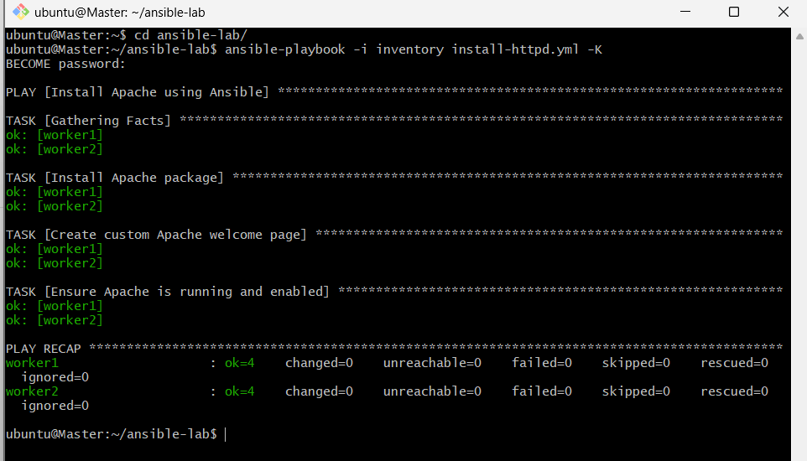
Step 11: Verify the custom welcome pages
ansible workers -i inventory -m command -a "cat /var/www/html/index.html"
Expected output:
worker1 | CHANGED | rc=0 >>
Apache installed using Ansible on worker1

worker2 | CHANGED | rc=0 >>
Apache installed using Ansible on worker2
If the playbook fails at Step 10 with the same privilege-escalation timeout, stop and share the error. We should resolve Ansible's sudo-password handling before retrying.
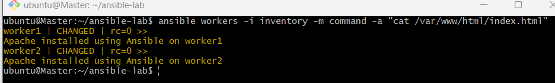
Step 12: Confirm the task is complete
ansible workers -i inventory -m command -a "systemctl is-active apache2"
Both workers should return active.
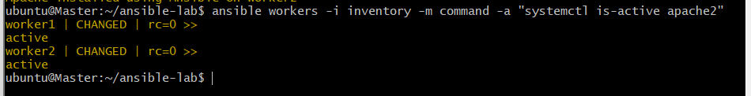

3.Write a ansible playbook to install apache tomcat.
Run this from the Master, so you don’t need to log in to the workers:
bash
cd ~/ansible-lab
ansible workers -i inventory -b -m command -a "apt-cache policy tomcat10 tomcat11 tomcat9"
For each package, look at the Candidate: line. A version number means it’s available. (none) means it isn’t. Pick the newest one that is available. I’ll use tomcat10 below, so replace it if yours is different.
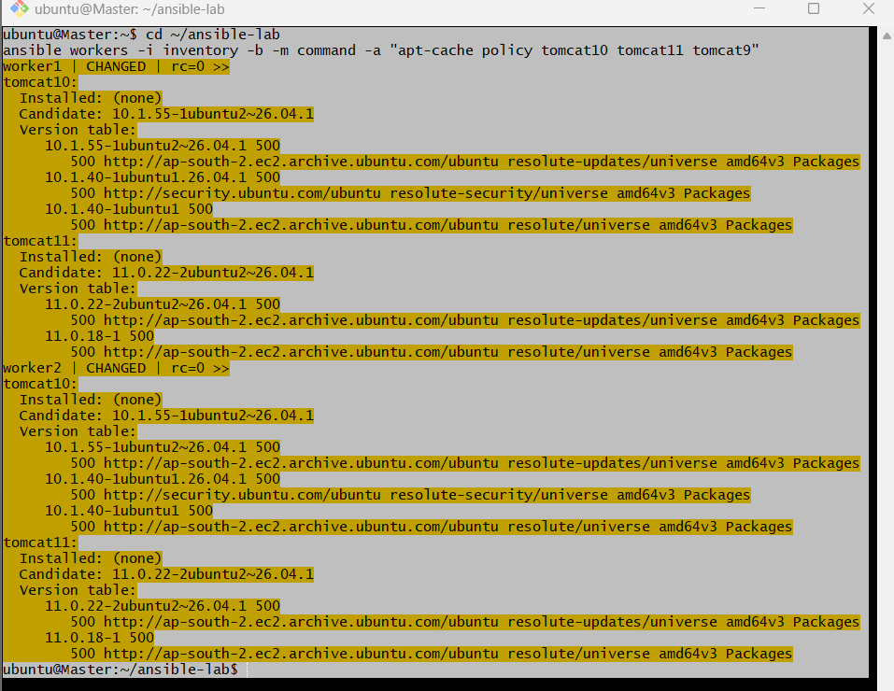
Step 2: Create the playbook
bash
nano install-tomcat.yml
Paste this:
yaml
---
- name: Install Apache Tomcat
hosts: workers
become: yes
tasks:
- name: Install Java (JDK)
apt:
name: default-jdk
state: present
update_cache: yes

- name: Install Tomcat and admin apps
apt:
name:
- tomcat10
- tomcat10-admin
state: present
notify: Restart Tomcat

- name: Ensure Tomcat is running and enabled
service:
name: tomcat10
state: started
enabled: yes

handlers:
- name: Restart Tomcat
service:
name: tomcat10
state: restarted
Save and exit (Ctrl+O, Enter, Ctrl+X).
Step 3: Check the syntax
bash
ansible-playbook -i inventory install-tomcat.yml --syntax-check
It should print the playbook name with no errors.
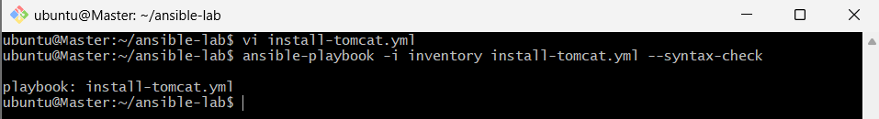
Step 4: Run it
bash
ansible-playbook -i inventory install-tomcat.yml
The first run takes a minute or two because it downloads Java and Tomcat. You should see changed on the install tasks and a recap with failed=0 unreachable=0 for both workers.
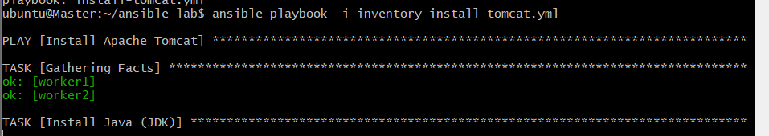
Step 5: Verify Tomcat is running
bash
ansible workers -i inventory -b -m command -a "systemctl is-active tomcat10"
ansible workers -i inventory -b -m command -a "ss -tlnp"
The first should return active. The second should show something listening on port 8080.
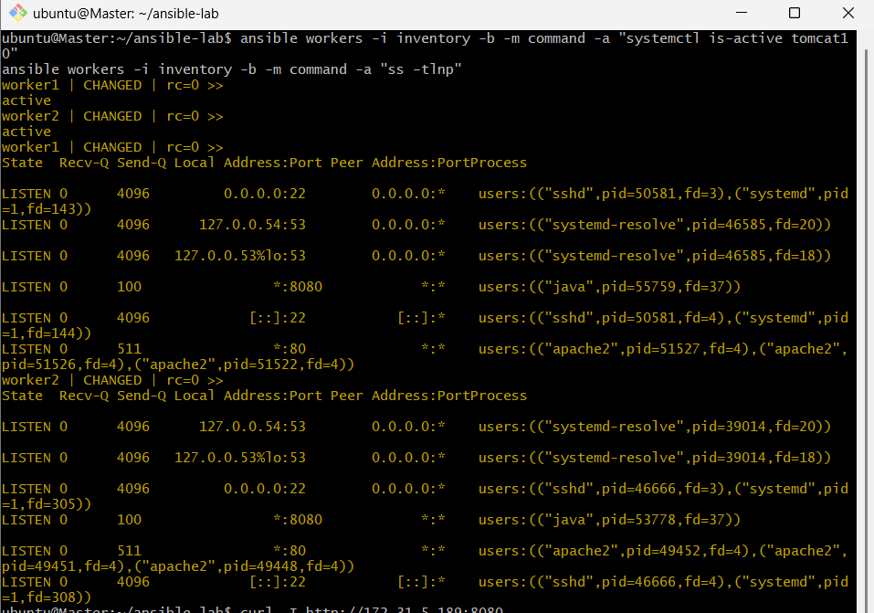
You can also test the web response from the Master using the workers’ private IPs:
bash
curl -I http://172.31.5.189:8080
curl -I http://172.31.11.14:8080
HTTP/1.1 200 means Tomcat is serving.
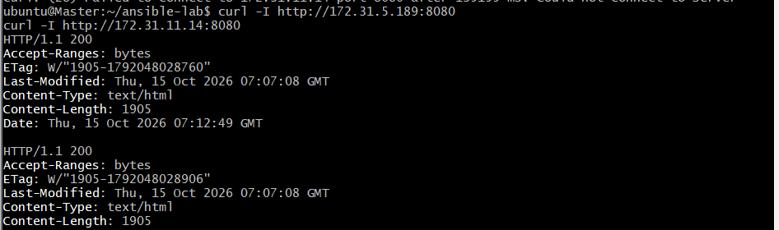
Step 6: See it in a browser (optional)
- In the EC2 console, open the workers’ Security Group, then Inbound rules, then Edit.
- Add a rule: Type Custom TCP, Port 8080, Source My IP. Avoid 0.0.0.0/0.
- Open http://<worker-public-ip>:8080 in your browser. You should see the Tomcat default page.
Apache (port 80) and Tomcat (port 8080) can run side by side, so there’s no conflict with task 2.
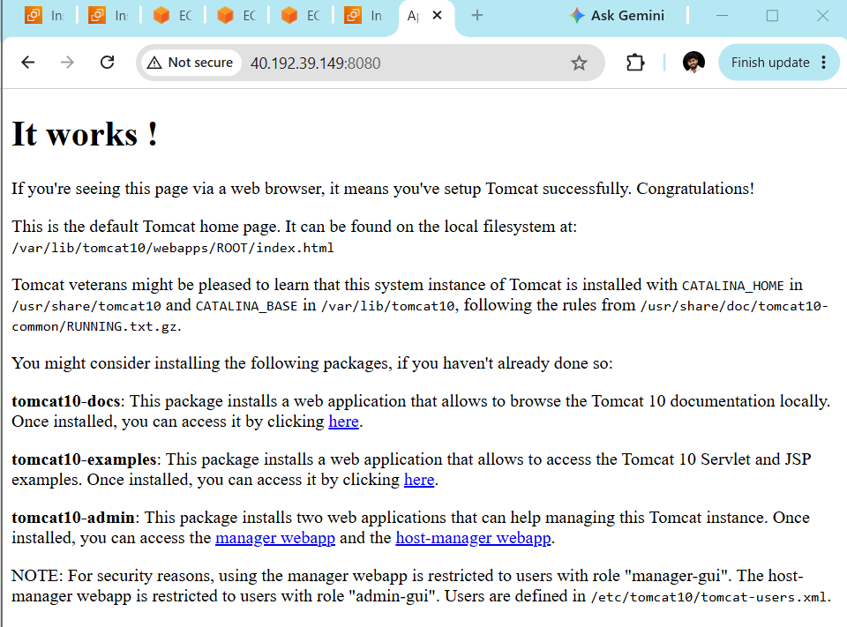

4.Write a ansible playbook to provision one ec2 on aws.
Step 1: Create the IAM role (AWS console)
- Open IAM > Roles > Create role.
- Trusted entity: AWS service, use case EC2. Click Next.
- Attach the policy AmazonEC2FullAccess. That’s fine for a lab; don’t use it in production.
- Name it ansible-master-role and create it.
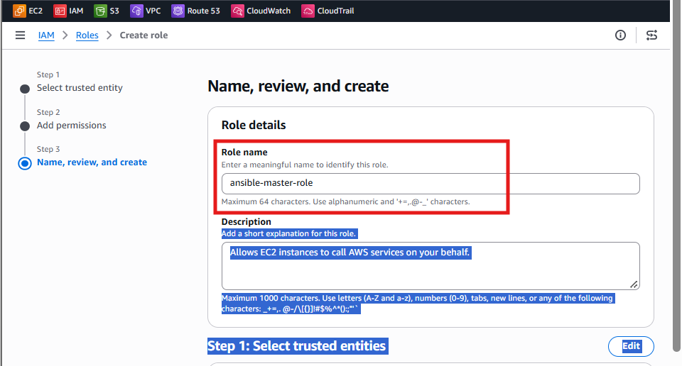
Step 2: Attach the role to the Master
- Open EC2 > Instances and select the Master instance.
- Click Actions > Security > Modify IAM role.
- Choose ansible-master-role and click Update IAM role.
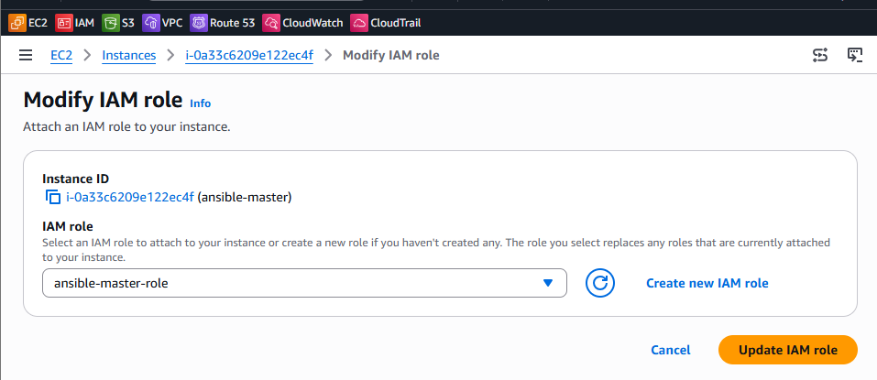
Step 3: Install dependencies on the Master
bash
sudo apt update
sudo apt install -y python3-boto3 python3-botocore
ansible-galaxy collection list | grep amazon.aws
If the last command prints nothing, install the collection:
bash
ansible-galaxy collection install amazon.aws
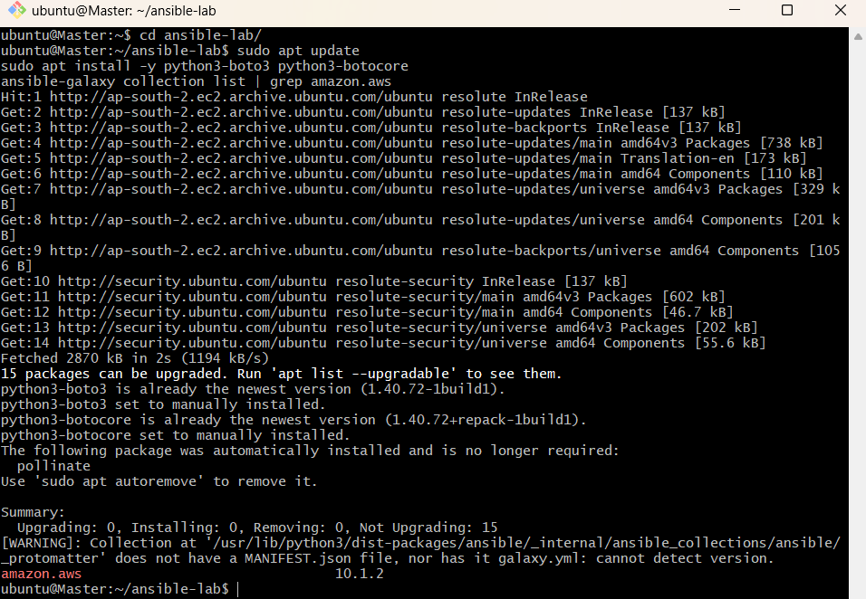
Step 4: Check that the Master has AWS permission
Your apt mirror (ap-south-2) suggests your region is Hyderabad, so I’ll use that.
bash
python3 -c "import boto3; print(boto3.client('sts', region_name='ap-south-2').get_caller_identity()['Arn'])"
It should print an ARN containing ansible-master-role. If it errors with “Unable to locate credentials”, wait a minute and retry, then confirm the role is attached in Step 2.
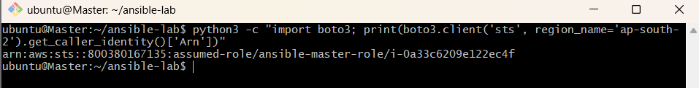
Step 5: Collect the values for the playbook
The Master can read its own details from instance metadata. Reusing its AMI, subnet and security group is fine for a lab:
bash
TOKEN=$(curl -sX PUT "http://169.254.169.254/latest/api/token" -H "X-aws-ec2-metadata-token-ttl-seconds: 300")
H="X-aws-ec2-metadata-token: $TOKEN"
M=http://169.254.169.254/latest/meta-data

echo "AMI: $(curl -sH "$H" $M/ami-id)"
MAC=$(curl -sH "$H" $M/mac)
echo "SUBNET: $(curl -sH "$H" $M/network/interfaces/macs/$MAC/subnet-id)"
echo "SG: $(curl -sH "$H" $M/network/interfaces/macs/$MAC/security-group-ids)"
You also need a key pair name. Find it in EC2 > Key Pairs, or use the one shown on the Master’s instance details page.
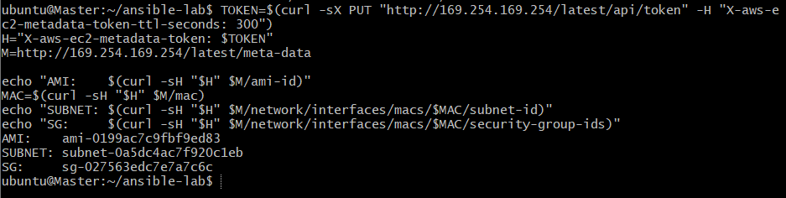
Step 6: Generate the playbook
bash
cd ~/ansible-lab
KEY=ansible-lab-key
AMI=$(curl -sH "$H" $M/ami-id)
MAC=$(curl -sH "$H" $M/mac)
SUBNET=$(curl -sH "$H" $M/network/interfaces/macs/$MAC/subnet-id)
SG=$(curl -sH "$H" $M/network/interfaces/macs/$MAC/security-group-ids)

cat > provision-ec2.yml <<EOF
---
- name: Provision one EC2 instance
hosts: localhost
connection: local
gather_facts: no
tasks:
- name: Launch instance
amazon.aws.ec2_instance:
name: ansible-lab-node
region: ap-south-2
instance_type: t3.micro
image_id: $AMI
key_name: $KEY
vpc_subnet_id: $SUBNET
security_groups:
- $SG
network:
assign_public_ip: true
wait: yes
state: running
register: ec2

- name: Show instance details
debug:
msg: "ID: {{ ec2.instances[0].instance_id }}, Public IP: {{ ec2.instances[0].public_ip_address | default('none') }}, Private IP: {{ ec2.instances[0].private_ip_address }}"
EOF

cat provision-ec2.yml
In the printed file, check that these show real values and not blanks:
- image_id: ami-0199ac7c9fbf9ed83
- key_name: ansible-lab-key
- vpc_subnet_id: subnet-0a5dc4ac7f920c1eb
- - sg-027563edc7e7a7c6c
If image_id or vpc_subnet_id are blank, H and M were lost (new terminal). Re-run the TOKEN=, H= and M= lines from Step 5, then redo this block.
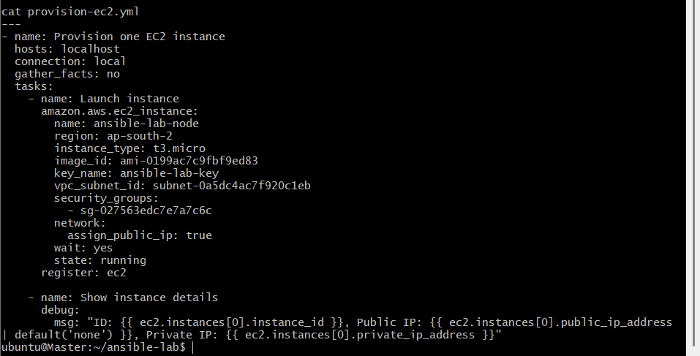
Step 7: Run it
bash
ansible-playbook provision-ec2.yml --syntax-check
ansible-playbook provision-ec2.yml
Expect changed=1 and a debug line with the instance ID and IPs. The run can take a minute while it waits for the instance to start.
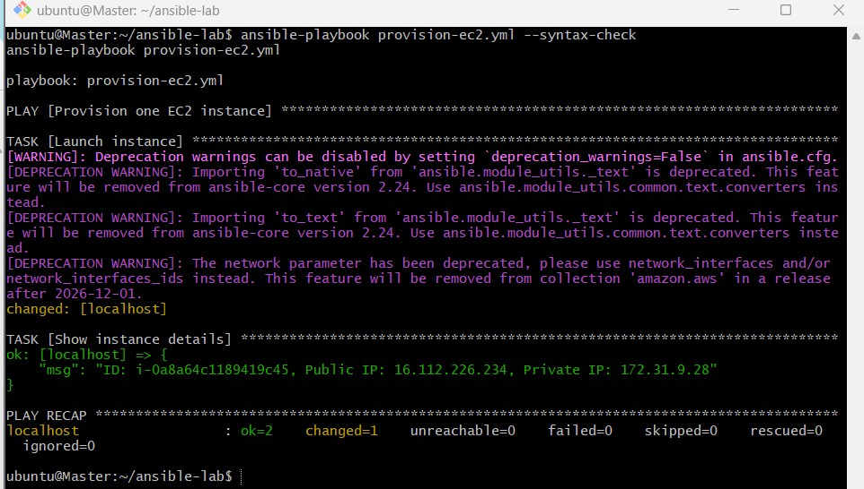
Step 8: Verify
- Open EC2 > Instances (region Asia Pacific (Hyderabad)) and look for ansible-lab-node in the running state.
- Run the playbook a second time. It should report changed=0, because the instance is matched by its name tag, so no second one is created.
Take your screenshot or notes for the assignment now.
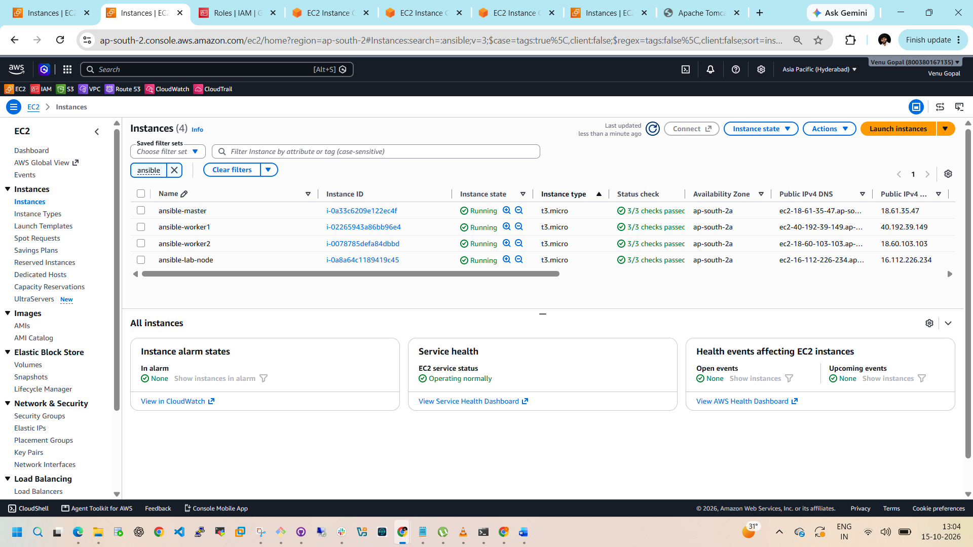
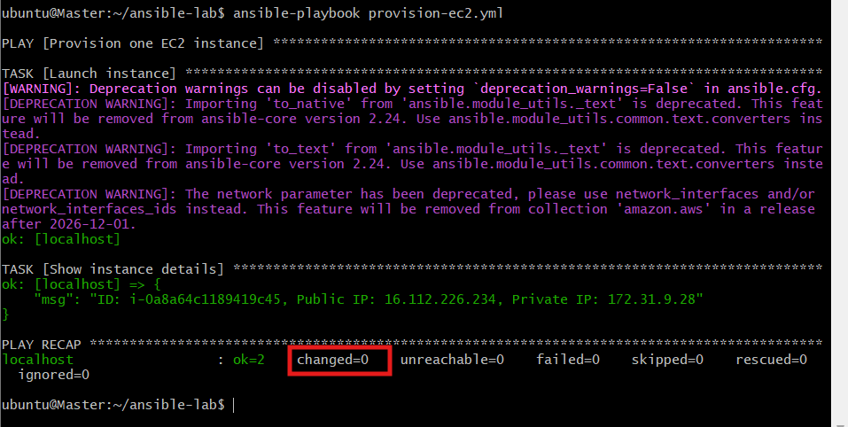
Step 9: Clean up so it doesn’t cost money
bash
cat > terminate-ec2.yml <<'EOF'
---
- name: Terminate the lab instance
hosts: localhost
connection: local
gather_facts: no
tasks:
- name: Terminate instance
amazon.aws.ec2_instance:
name: ansible-lab-node
region: ap-south-2
state: absent
wait: yes
EOF

ansible-playbook terminate-ec2.yml
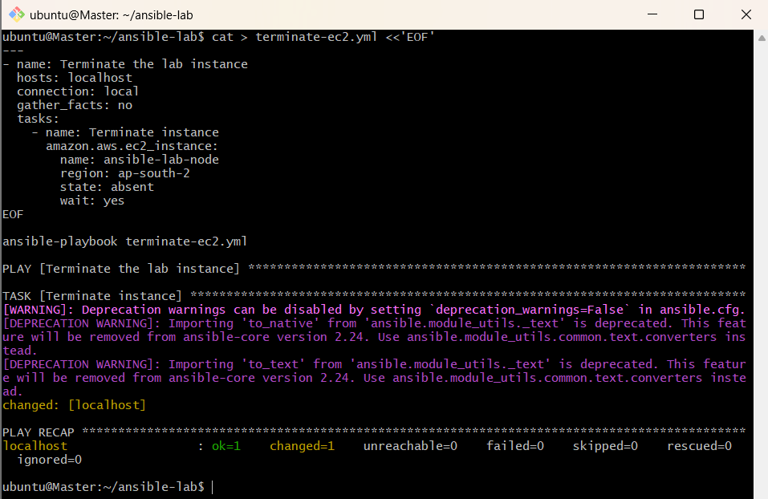

Task 5: Copy a file from node-1 to node-2
Ansible has no simple direct node-to-node copy, so the playbook pulls the file from worker1 to the Master and then pushes it to worker2. I’m using worker1 as node-1 and worker2 as node-2, matching your inventory.
Step 1: Create the playbook
bash
cd ~/ansible-lab
nano copy-node1-to-node2.yml
Paste:
yaml
---
- name: Fetch file from node-1
hosts: worker1
become: yes
tasks:
- name: Create a sample file on node-1
copy:
content: "Hello from worker1\n"
dest: /tmp/sample.txt
mode: '0644'

- name: Fetch the file to the Master
fetch:
src: /tmp/sample.txt
dest: /tmp/fetched/sample.txt
flat: yes

- name: Copy file to node-2
hosts: worker2
become: yes
tasks:
- name: Push the file to node-2
copy:
src: /tmp/fetched/sample.txt
dest: /tmp/sample-from-node1.txt
mode: '0644'
Save with Ctrl+O, Enter, Ctrl+X.
The file lands on worker2 as sample-from-node1.txt, so you can tell it came from worker1.
Step 2: Check the syntax
bash
ansible-playbook -i inventory copy-node1-to-node2.yml --syntax-check
Step 3: Run it
bash
ansible-playbook -i inventory copy-node1-to-node2.yml
Expect changed on the create, fetch and push tasks, and failed=0 in the recap. There are two plays in the file, so you’ll see two recaps’ worth of tasks.
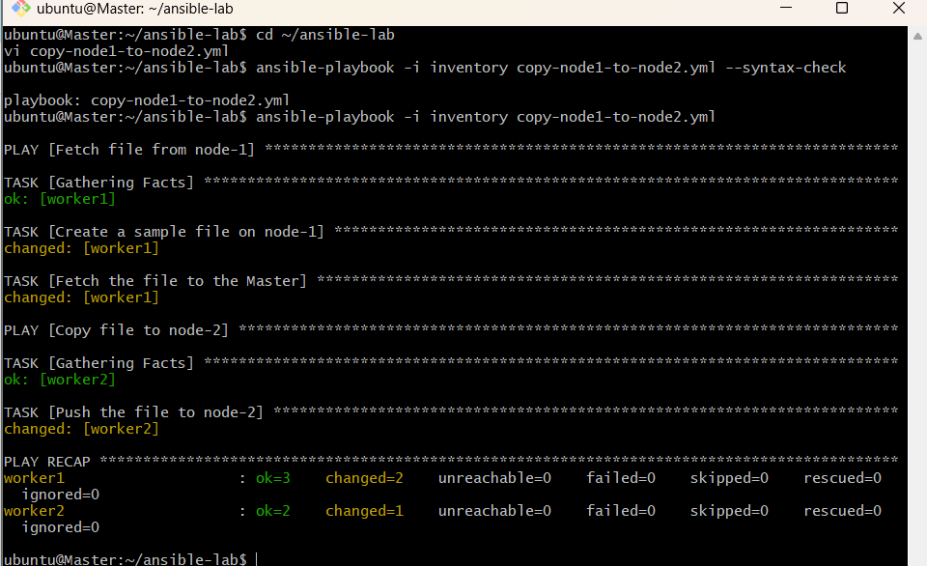
Step 4: Verify
Check the file on both nodes:
bash
ansible worker1 -i inventory -b -m command -a "cat /tmp/sample.txt"
ansible worker2 -i inventory -b -m command -a "cat /tmp/sample-from-node1.txt"
Both should print Hello from worker1. You can also see the copy on the Master:
bash
cat /tmp/fetched/sample.txt
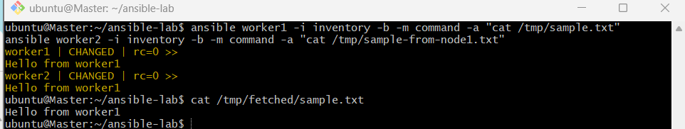
Step 5: Idempotency check
Run the playbook again. The create and push tasks should report ok, but the fetch task may show ok or changed depending on the version, which is normal. Worth a line in your notes either way.
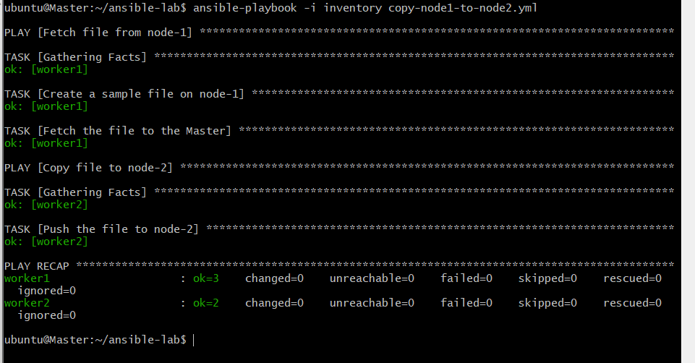

Task 6: Create different files with different names using one playbook
The playbook uses a loop, so one task creates several files.
Step 1: Create the playbook
bash
cd ~/ansible-lab
nano create-files.yml
Paste:
yaml
---
- name: Create different files with different names
hosts: workers
become: yes
tasks:
- name: Create files with different content
copy:
content: "This is {{ item }} on {{ inventory_hostname }}\n"
dest: "/tmp/{{ item }}"
mode: '0644'
loop:
- file1.txt
- report.log
- notes.md
- config.conf

- name: Create empty files with different names
file:
path: "/tmp/{{ item }}"
state: touch
mode: '0644'
modification_time: preserve
access_time: preserve
loop:
- empty1.txt
- empty2.txt
- empty3.txt
Save with Ctrl+O, Enter, Ctrl+X.
The first task creates files with content, and the second creates empty files. The modification_time: preserve and access_time: preserve lines make the second task idempotent, so it reports changed=0 on a re-run instead of touching the files every time.
Step 2: Check the syntax
bash
ansible-playbook -i inventory create-files.yml --syntax-check
Step 3: Run it
bash
ansible-playbook -i inventory create-files.yml
Expect changed for each item on both workers, and failed=0 in the recap.
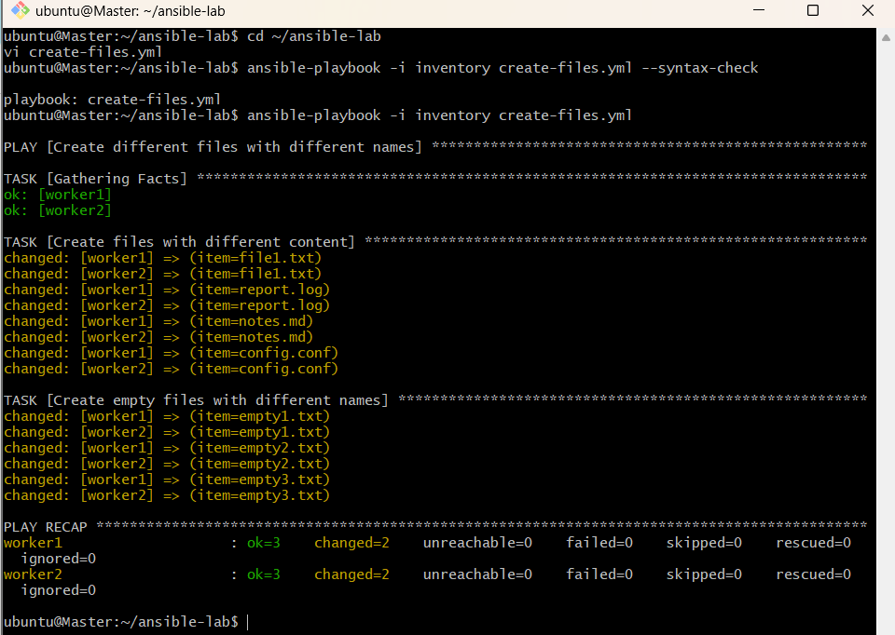
Step 4: Verify
bash
ansible workers -i inventory -b -m command -a "ls -l /tmp"
ansible workers -i inventory -b -m command -a "cat /tmp/file1.txt /tmp/report.log"
You should see all seven files on both workers, and each one with content should mention its own hostname.
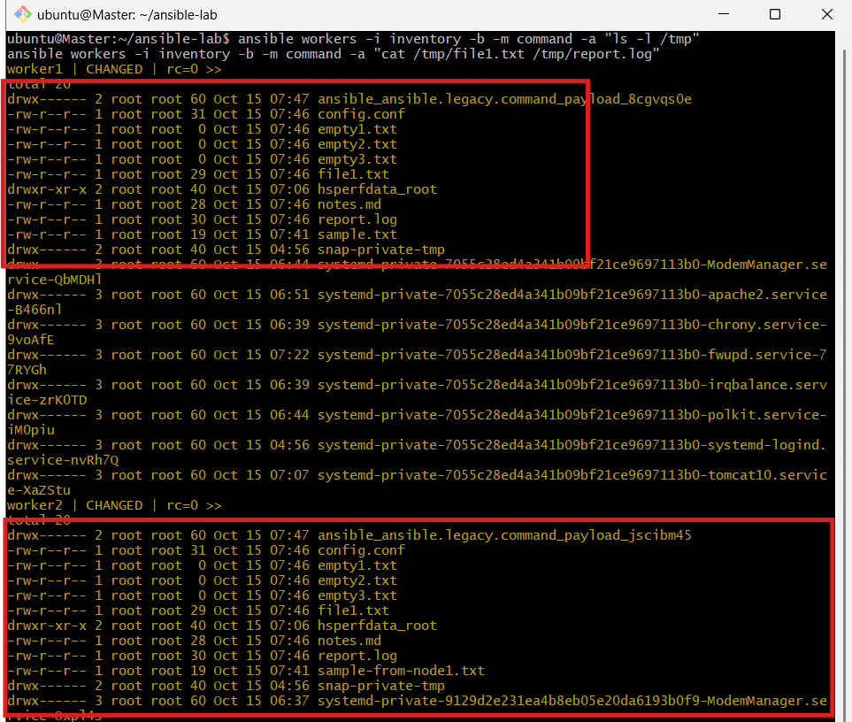
Step 5: Idempotency check
Run the playbook again. It should report changed=0 for every task.
